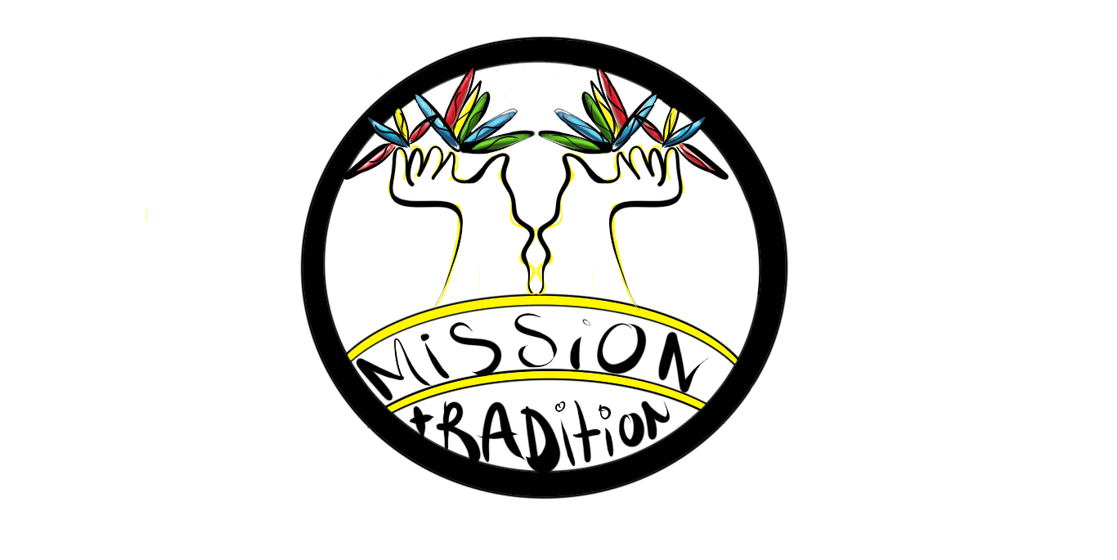
ESC APPLICATION FORM
Thank you for deciding to apply for an ESC project in YEU Cyprus.
Please fill in all information and answer all questions (keep your answers short and focused! We are looking forward to learning more about you!

Personal Data

Name: |  |  |  |  | Surname:
Email: |  |  |  |  | Date of Birth:
Gender: | Male |  |  | Female |  |  |  | Other
Nationality: |  |  |  |  | Country of Residence:
Address: |  |  |  |  | Postal Code: |  |  |  | City:
Phone Number: |  |  |  |  | Occupation/  Profession:
Do you have any health conditions, allergies, dietary or other special needs that the hosting organization should be aware of?
If yes, please explain.
These are characteristics for young people with fewer opportunities - please write ‘yes’ in the space provided if any of the categories applies to you.  (ESC is committed to support inclusion from those who may have faced difficulties) |  |  | Social Difficulties (facing discrimination because of gender/ethnicity/ religion/sexual orientation/disability, etc.; (ex)offenders, (ex)drug or alcohol abusers, orphans, young people from broken families
 |  |  | Cultural Differences (ethnic minority; immigrants/refugees or descendants of them)
 |  |  | Economic Difficulties (low income, dependence on social welfare system, unemployment or poverty, financial problems, homeless).
 |  |  | Disability (physical, sensory, mental, other)
 |  |  | Health Problems (chronic health problems, severe illnesses)
 |  |  | Geographical obstacles (Rural areas, islands, urban problem zones)
 |  |  | Educational difficulties (learning difficulties, school dropouts, lower qualified, poor school performance)
If you answered ‘yes’ to any of the above categories, please explain.

Motivation and Experience

- Have you done any volunteering work in the past? (If yes please tell us about it)

- What relevant education or work experience have you had?

- What do you like to do in your free time?

- Why are you interested in this project? Are you especially interested in any specific task?

- How did you find out about us and this EVS?

- What are your expectations and what do you hope to gain personally and professionally from your EVS experience? What would you like to learn?

- How can you contribute to the implementation of the project activities?

- The activities in this project will require you to work in a team. How would you describe your team work abilities?

- Are you willing to interact with different cultures and young people of different nationalities?

- What challenges do you think you will/might face during your EVS experience?

- Have you ever lived away from home or abroad? Where and for how long? What was the experience like for you?

- What might be your plans after you complete the EVS project, or what would you do if you are not selected for this project?

Personality Traits

Please tick what you think describes you best  (wrote x in blank spaces) | I am a leader
 | I am a follower
 | I listen to others first then I say my opinion
 | I do only what I believe is correct
 | I follow all the rules even if I disagree with some of them
 | I impose my beliefs and opinions on others
 | I consider myself that I speak a lot
 | I consider myself that I’m quite
 | I consider myself as a team player
 | I can communicate with others easily
 | I have some difficulties in communicating with others
 | I consider myself as a patient person
 | My mood changes fast
 | I try new things
 | I prefer doing only what I know
 | I enjoy being around or working with children
 | I’m passionate about environmental issues

Language Skills

Please tick (write x) according to your speaking and understanding level of English and any other languages that you speak. | Language level: | basic | intermediate | advanced
 | ENGLISH
 | (other)
 | (other)
 | (other)

Next steps to apply

Please send this application together with your CV and Motivation Letter to evs@yeu-cyprus.org by the 28th of February 2019.

We will send you a confirmation email within 3 working days (confirming that we got your application) and timely inform you about the results of selection.

DISCLAIMER: In accordance with the EU’s General Data Protection Law, we as YEU Cyprus, hereby declare that the personal data submitted, are collected legally fairly and in a transparent manner. Your data will be stored for 5 years from the date of your application. At the end of those 5 years all information will be deleted from our database.

THANK YOU for the time to fill in our application form!

